During the Messinian Salinity Crisis (MSC), closure of the straits connecting the Mediterranean Sea with the Atlantic Ocean led to the evaporation of much of the Mediterranean Sea. This produced a canyon much larger than the Grand Canyon and with a depth of up to 2000 m. In this study, we used an atmospheric climate model from the National Center for Atmospheric Research (NCAR) to simulate the Messinian Salinity Crisis.
The control run simulates the present day Mediterranean Sea but we do not allow the Atlantic Ocean to transport any energy or heat into the Mediterranean Sea. We did this because when the African and European continents collided it isolated the Mediterranean Sea from the Atlantic Ocean. Therefore, no heat or energy was transported into the Sea at the start of the MSC. The Lowered Sea (LS) and Lowered Land (LL) are the two experiments where the sea level was reduced over the Mediterranean Sea. In the LL case the surface of the basin was converted to land. This was done to simulate a completely dried up basin. We also tested the sensitivity of adding land over the Mediterranean Sea in the model by running an Upper Land (UL) simulation. In the UL case we covered the Mediterranean Sea with land and added some vegetation (mostly shrub and grassland), but the level of the surface was not reduced.
We must understand the climate of the Mediterranean region before we look at the changes to the climate in our experiments. The Mediterranean Sea is located between 30ºN and 45ºN, and lies beneath the descending branch of the Hadley cell circulation. The Hadley cell circulation is responsible for transporting warm air from the tropics towards the poles. Warm air rises near the equator and is transported polewards in the upper layers of the atmosphere. It cools and sinks around 30º latitude in the Northern Hemisphere. As air sinks in the atmosphere the atmospheric pressure increases. This will squeeze the parcel of air and the molecules inside the parcel will start colliding with one another. Since temperature is just the measure of kinetic energy the more the molecules collide the warmer the air parcels will become. Therefore, as air sinks it warms. It warms by the adiabatic lapse rates, which are about 9.8 K/km for dry air and 6.5 K/km for moist air. The warm sea temperatures and high atmospheric moisture of the Mediterranean Sea is in marked contrast to the surrounding deserts to the south and east and mountains to the north. A strong seasonal cycle (Peixoto et al., 1982) exists in which the winters are wet and cool and the summers remain dry and warm.
Lowering the Mediterranean Sea Level up to 2000 m results in up to a 160 mb surface pressure anomaly (Fig. 1) over the Mediterranean basin. An anomaly is just the difference between the experiment and a control run. This anomaly is not present in the UL case because we did not lower the surface.
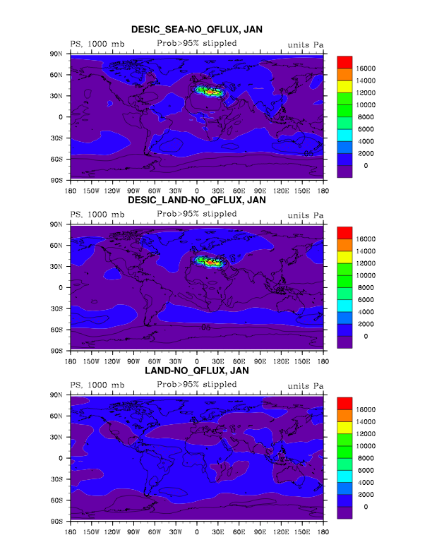
Figure 1: The difference in Surface Pressure between the three cases (LS, LL, and UL) and the control (US).

Locally, changes in the sea level of the Mediterranean basin result in changes in the pressure, temperature, precipitation, and wind fields. The most striking response to the LS experiment is a distinct warming of the Mediterranean basin during the winter (Fig. 2). As air subsides into the lowered sea it is heated adiabatically. Compressional heating creates a very hot basin as the surface temperature warms by more than 10 K. However, when we cover the dried up basin with land (LL), we do not see this abrupt warming in the winter. This is due to differences in the heat capacity, which is much less for land than water, and the diurnal cycle. The heat capacity is just the amount of energy required to raise the temperature of a substance one degree. It takes much more energy to raise the temperature of the ocean surface that it does to raise the temperature of the land surface. During the day the land surface will heat up rapidly, but at night it will rapidly cool down. Thus taking the average will get rid of this maxima and minima and the difference between the LL and UL from the US is relatively small compared to the change between the US and LS.
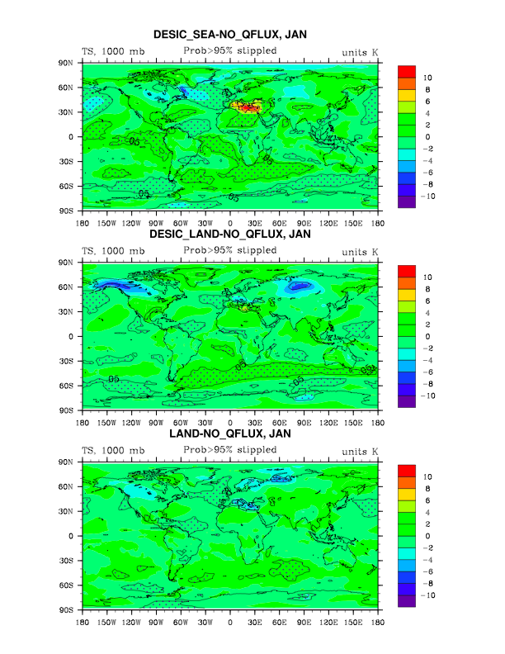
Figure 2: The difference in the Surface Temperature between the three cases (LS, LL, and UL) and the control (US).

The strong heating leads to rising air over the lowered basin. A strong low-pressure anomaly develops over the Mediterranean region and Western Europe (Fig. 3) in the LS case. Rising air leads to uncharacteristic low-level wind convergence over the hot lowered basin. In this region, the sea level pressure is reduced up to 1000 Pa and is spread from the Mediterranean Sea northwestward into France and Spain (Fig. 3). By contrast with the normally primarily zonal winds in the Mediterranean, the LS wind vectors show a strong southerly wind component over the central and eastern Mediterranean Sea (Fig. 4) for the LS case. This southerly wind pushes air up the slope of the northern edge of the basin. Remember at the edges of the dried up basin there are large sloping land surfaces. The upslope flow and convergence leads to enhanced precipitation in the Alps.
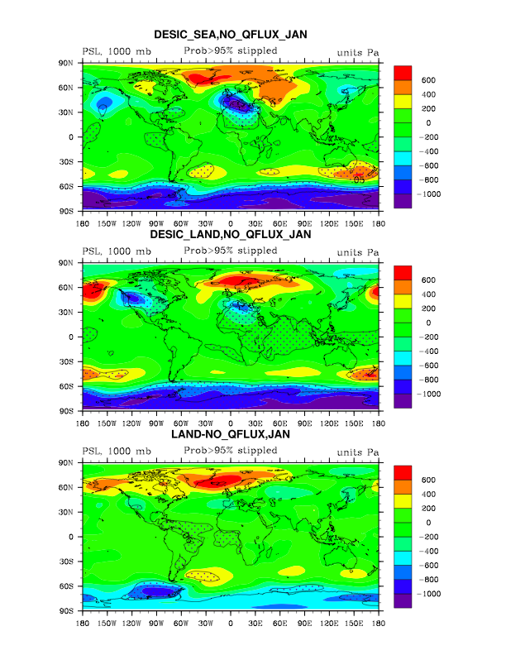
Figure 3: The difference in Sea Level Pressure between the three cases (LS, LL, and UL) and the control (US).

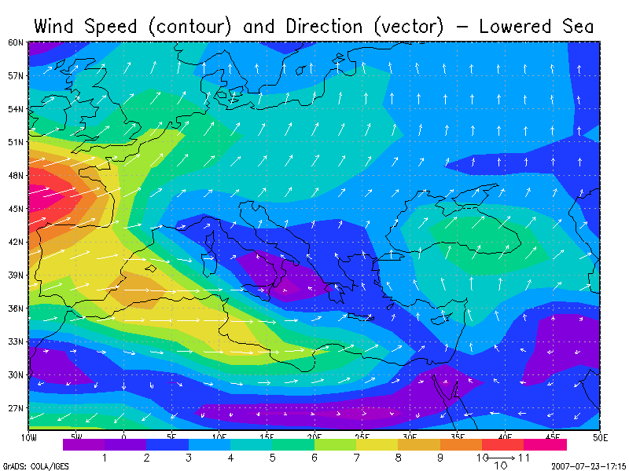
Figure 4: The LS wind field for January over the Mediterranean region.

The LS experiment results in a significant increase in winter convective and large-scale precipitation over Northern Italy (Fig. 5). The winter precipitation anomaly over the Alps reaches a maximum of 1500 mm yr⁻¹.
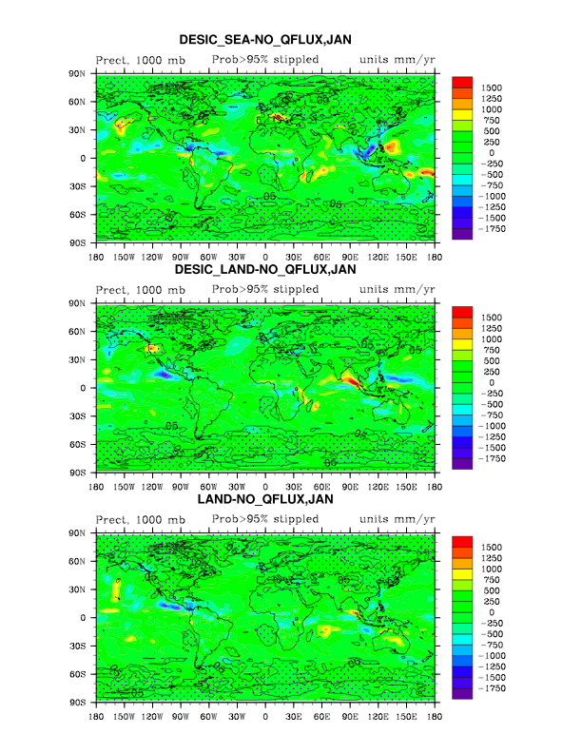
Figure 5: The difference in Precipitation (large scale and convective) between the three cases (LS, LL, and UL) and the control (US).

The climate implications the MSC are both vast and numerous. Atmospheric and hydrospheric changes are not confined to the local region, but instead propagate globally through variations in the storm track.

